**Chapter 1**

**ORGANIZATIONAL PROFILE**

Sookshma Chetas Softwares Pvt. Ltd. is a Software Company with a common goal of innovative and creative ideas and software solutions in the information technology industry.

Started with the main goal of customer satisfaction, Sookshma accelerates through the services like Web Design and Development, E-commerce Web Development, Mobile Applications, Software Development, Search Engine Optimization and Responsive Designs. Blended with values, sustainability, quality, ethics Sookshma can contribute to the success and growth of the client’s business. The company ensures that their services prove to be reliable, efficient and cost-effective. Sookshma Chetas has its clients spread across states in various sectors.

The company’s areas of work are mainly Web Designing, Graphic Designing, Search Engine Optimization, Email Hosting, Web Hosting, Application Development, Logo Designing, Brochure Designing, Business Cards Designing, Packaging and Labels Designing.

It serves as a platform and provides great opportunities for designers to exhibit their skills.

* 1. **SERVICES OFFERED**

**Graphic Designing:** Sookshma Graphic Designing is an integral part of the esteemed company. They make products get attention in the market by implying lots of theme based branding for it. They understand how to bring out corporate messages via artistic and professional creations that graphically entice customers to go for the product or service. With a dedicated team of expert Graphic designers, we ensure the best quality of designs that would match all the needs. The objective is to achieve an exclusive look and unique positioning in niche market for the esteemed clients. Services offered are as follows:

* Logo Designing
* Brochure Designing
* Business Cards
* Packaging and labels
* Banners and Posters

**Search Engine Optimization :** There are a large number of strategies that can be used to optimize a website for search engines. At Sookshma Chetas Softwares Pvt. Ltd. they are having a team of highly experienced software developers who are bringing up an exclusive SEO services. There are many ways to drive new users to homepage, search engines are among the best at bringing new visitors to their door. Having a great Web site is simply not enough. Millions of people use search engines every day to scour the Internet and find information from relevant Web sites. The point is to make the best out of the lot! Search Engine Optimization is a critical component of a well-rounded Internet marketing strategy. Sookshma SEO can bring thousands upon thousands of visitors to their website a day. This may put the company in a position of needing to expand to a larger web server to accommodate the traffic and sales to their website. Using SEO will make the brand stand out from the rest and can easily be the boost that they need to see their sales go through the roof.

**Email Hosting :** Email Hosting is an internet hosting service which manages electronic messages through an email server. Sookshma Chetas offers a very effective, robust Email Hosting service for small to medium business enterprises at a very low cost. Having an own branded email is necessary for any business irrespective of the size. We allow users to create a variety of email types which utilize the same trailing address. The Email Hosting Packages provides variety of options to create and manage the internal email addresses. All the email hosting packages come with very high secure features, thus ensuring safety at its best! Technology you can trust! Bridging technology with Innovation!

**Web Hosting :** A Reliable, easy and highly fast Web Hosting Service is here for you. Stay connected wherever you are. The Web Hosting provides ultimate security and safety ensuring reliability. Choose among the different packages offered at a reliable cost. Quality and Reliability matters when you have to go in for the right one. Sookshma, which is ever concerned in providing excellent service, provides the best Web Hosting Service in the market today. Lots of space, loads of safety is what we assure.

**Application Development:** Software Development Services: Software Development is the integral part of Sookshma. Building technology to the ever growing innovative ideas, we provide services par excellence in the field of Software Development. Be it end-to-end solution development, or developing intermediary building blocks in the system, Sookshma handles it with ease. Sookshma Software development services are centered on providing high quality effective software that is just right for you! Success and Progress go hand in hand with quality and innovation as the main motto.

**Android Development Services**: The talk of the day is 'Android' everywhere! With seasoned Android Developers, we pledge to provide amazing Android Apps which is the call for the day! Wrapped with excellent talent and quality, we make sure you are satisfied with the apps we come up with. Android has the power to completely alter the look, feel and functions of a mobile device. The beauty of Android is that third party apps can be created with Java and the Android framework. Understanding the present market trend and customer views, we at Sookshma are thoroughly exercising their talent to develop the best apps. The dedicated team of Android developers provides exuberant service at all times.

* 1. **PRODUCTS**

1. **SOOKSHMA STOCKS-BSE:**

It is a powerful app for Android to analyze the Indian stock market's (Bombay Stock Exchange, BSE ) technical trends graphically. Sookshma Stocks provides the multiple graph (multiple Stock Charts) comparison facility in the easiest way which helps the investor to compare, analyze and decide about the action towards investment in any stock.

Sookshma Stocks provides the following comparisons and facilities:

**Indices-Indices Comparison:** Indices-Indices Comparison helps investor to compare and choose the best index to invest in.

**Sector-Sector Comparison:** This Comparison helps to choose the best sector at any point of time to invest in.

**Stock-Stock Comparison:** In this comparison, investor can pick multiple stocks followed by index sector selection or they can also build graphical stock-watch to watch and analyze their favorite stocks.

**Indices-Sectors-Stocks Comparison:** This is the comparison where the investor can perform all the three comparisons at once. This comparison helps the investor to analyze the technical trends of the stocks with respect to Index and Sector.

**Sookshma Stock- Portfolio:**Sookshma Stock Portfolio is a powerful tool to save and track the investments easily and precisely.

1. **SOOKSHMA Jagat Nasdaq:**

It is a powerful app to analyze the stocks graphically with a multiple charting facility on a single screen, this helps you to build a graphical stock watch, indices watch and sectors watch. In the app you can manage the portfolio with live price streaming, buy/ sell, transaction history and profit/ loss reports.

SOOKSHMA Jagat also provides the following comparisons and facilities for you:

**Indices-Indices Comparison**: Indices-Indices Comparison helps investor to compare and choose the best index to invest in.

**Sector-Sector Comparison**: This Comparison helps to compare and choose the best sector at any point of time to invest in.

**Stock-Stock Comparison**: In this comparison, investor can pick multiple stocks followed by index sector selection or they can also build graphical stock-watch to watch and analyze their favorite stocks.

**Indices-Sectors-Stocks Comparison**: This is the comparison where the investor can perform all the three comparisons at once. This comparison helps the investor to analyze the technical trends of the stocks with respect to Index and Sector.

1. **SORMS.IN:**

An Online Shopping or Online Retailing is a form of electronic commerce that allows to directly buy goods from seller over the internet. Customers are attracted to online shopping not only because of high levels of convenience, but also because of broader selections, competitive pricing, and greater access to information. One such exciting shopping experience can be had from the sorms.in, the most user-friendly website in which one can find anything and get anything at one place!

sorms.in is an esteemed product of Sookshma Chetas Softwares Pvt. Ltd. It is the most advanced and modern local search engine and online shopping portal, where one can list their business, shop online and browse over for their desired stores. It provides customer accounts where user can get all the details concerning to his shopping.

Consumers can find any product of their interest by visiting sorms.in directly. sorms.in describes products with text and photos which reduces the time of searching each and every product and makes shopping easy, as all products are available just by a click! Whereas in a physical retail store, the actual product and the manufacturer's packaging will be available for direct inspection making it a tedious search. It is a highly secured website. It is made very safe for users.

It is easy to navigate and browse for all purchases. It has a product catalog that customers can use to browse the search criteria, information about the products, the sellers, and the service center. Irrespective of only online shopping, it facilitates all kinds of services from stores/business. It has a unique feature called **'Enquiry' and 'Product Enquiry'**, where users apart from shopping online can get information about any store/product by just sending a message. Enquiry also works very efficiently. User can enquire with the store about anything he wants.

Users are facilitated with SMS alerts and the store will get back to the user via mail. Online shopping has become very popular nowadays, especially with the lifestyles of people who are always busy and are looking for a convenient way to shop. Here we introduce sorms.in - the solution for all online services! It helps the store by introducing them globally where the store is made open for customers widespread all over the world. This would in turn enhance and expand the sales opportunities of the store.

### Top Features of sorms.in:

### a.) Online Shopping

sorms.in is not just a good looking website with dynamic technical features, but it is user-friendly website that helps build a relationship between stores and customers. Online Order System in sorms.in gives the user an ability to browse over the category leisurely, increasing a great user-friendly experience to them. It allows you to have an unlimited listing of products. A very well managing and updating of products can be done in a precise manner. The online shopping is identified by a unique icon with four dots. To shop online you just have to register in sorms.in where a unique Customer ID and a PIN will be given. Users can browse through a large category of stores through the search tab which allows direct search as well as search by locator. Searching can be done either by entering Store Name, ID, Category, Sub-Category, PIN Code, and Address of any choice. It takes the desired store to the door-step. While you choose the desired products by a few clicks, online shopping will be done in just minutes. Users will be facilitated with SMS alerts, so that they can keep track of what they have ordered. It provides excellent reporting system where user can get all the details about the sales and purchase that has been done. It even facilitates the user with Profit-Loss, VAT, Monthly, Quarterly, Half-Yearly and Annual reports. The user will have a **'feel good'** shopping experience with sorms.in.

### b.) Enquiry

It has another unique feature called 'Enquiry'. Users can search for their desired business through the Direct Search/Locator by entering Store Name, Address, ID, PIN Code, Category, and Sub-Category. The Enquiry is uniquely identified by an icon with two dots. You do not have to wait in a line or wait till the shopkeeper is ready to help you with the purchases. One can do their shopping in minutes even if you are busy. It gives you the opportunity to shop 24 x 7. The choices you can get for products are amazing. One can get several brands and products from different sellers at one place. A list of all the stores will be populated for the user to choose. Once the store is chosen, user can send an enquiry to the particular store which will be notified to them through mail and SMS. Further, when the store receives the enquiry from the user, they reply to it. The user also gets SMS alerts. Enquiry makes the online experience very smooth!

### c.) Product Enquiry

sorms.in has an exciting feature called 'Product Enquiry'. This feature allow the user to access a wide range a products from stores, where user can send an enquiry about a particular product. Sometimes it would be difficult to get right information about a product as there may be fluctuations in price, updated features in the products. The Product Enquiry can be easily identified by the icon P/S Enquiry with three dots which means Product/Service Enquiry. It allows you to have an unlimited listing of products. A very well managing and updating of products can be done in a precise manner. To facilitate the users with a new feature, product enquiry does the job for you! The enquiry may be about a product's price, features, availability and so on. User can send the enquiry and get the required details.

### d.) Contact:

Users can browse through a large number of stores where-in they can find the store information and contact details(Address, Phone Number etc.) The Contact is indicated by an icon with a single dot. This unique feature simplifies the search for the desired store and user can easily find the contact. Thus, sorms.in helps you Find Anything! Get Anything!!

1. **SORMS BILLING:**

In a Competitive World of Business more than just managerial vision and excellent staff, you need to manage information with a superior retail management service, which is best offered by SOOKSHMA.

SORMS provides a real-time information with which user can analyze a complete business view and enhance predictability and thus profitability. By using SORMS Reporting System that acts as a 'digital nervous-system' of user's entire business, gives a complete summary retrieved through the enterprise network. SORMS works best for most of the retail business' like General Provision Stores, Automobile Shops, Footwears, Jewellery Shops, Pharmacies, Hardware Shops, Stationary, Dairy Parlors, Automobile Spares, Electronic Goods & Spares, Sweet Shops, Computer Shops, Garments and Textiles, Restaurants and Bakeries, Furniture Shops, Interiors and lots More.

**Overview**

SORMS offers a system that helps integrate a wide spectrum of user requirements, streamlining business and increase organizational efficiency with a definite mark of quality and assurance. We also offer a Comprehensive range of strategic, functional and technical expertise focused exclusively on retail in a very simple, user-friendly and cost-effective manner.

### SORMS Features

**Purchase Management:** SORMS Purchase Management helps to focus on the strategic side of the business, tracking marketing trends, customer preferences, price trends, cost efficiency, and managing the supply chain. This includes evaluating and qualifying vendor partners, improved negotiations and support the merchandising strategies.

Effective Purchase Management requires the knowledge of supply chain. This helps the user to plan, execute and oversee purchasing strategies that are conducive to profitability. The Purchase Management is very important, as a part of business, its good management technique directly impinges on the bottom-line. One of the fundamentals of purchasing is that, goods are purchased at the best price and terms in order to deliver the best profit!

**Stock Management:** SORMS Stock Management minimizes the cost of holding stocks whilst ensuring that there are enough materials in store to satisfy the needs of the user. A good stock management as such will lower the costs, improve efficiency and ensure safety to the user. It helps taking care of bulk buying and time managing. It increases sales through innovation, helps create new marketing opportunities. The System is thus adaptable, flexible, secure and accountable. SORMS Stock Management provides reports that take just minutes to setup new products and supplies! It helps control clients' total time by allowing to concentrate and dedicate more time to the core business by a streamlined process offered by the system. It is completely adaptable to the user, giving a tailored solution they need. It controls all the stock movements with full stock history, reporting facilities. Users are provided with a customized catalogue for user friendly functionality. Thus, helping the user manage and monitor the system with ease.

**Sales Management:** A Sale may take time and multiple interactions with a lead. SORMS Sales Management aides in the process of lead nurturing by keeping a track through reports. Any Information needed is clearly obtained and the system can access information on all the sales leads in one place and can anticipate and meet requirements as and when the need arises. SORMS Sales Management also allows the user to look at the customer's buying trends historically and look for patterns in their behaviors which will mean, the user can contact them at the suitable times for easy transaction. It also involves the activities of formulation of sales strategy through account management, sales plan, thus ensuring development and implementation of performance, monitoring and analysis.

**Inventory:** The technique of maintaining size of inventory at some desired level keeping in view the best economic interest of an organization is provided at its best by SORMS Inventory Management. At the heart of every good retail management software package lies powerful inventory management system that lets the user know:-  
\*What we have  
\*What user wants  
\*When he needs it  
**Accuracy in Inventory**  
With the Inventory, the user gets minute reports on the stock, order and transit. The user needs no more 'assuming' or 'thinking' as the inventory in the software takes optimum care in helping the user reach all the required minute details that a particular stock comprises. Accurate recording of all inventory transactions lead to better inventory management and increases service levels by preventing last sales opportunities to retailers. The SORMS Inventory System keeps track of the stocks that are selling best! and those that are not. This is a great way to identify THE STOCK the user can make effective use of.

**Online Orders:** SORMS provides a key component with a complete, highly automated and robust Online Order System. The SORMS Online Order System gives the consumer the ability to browse over the menu leisurely, increasing profitability and comfortability of user and consumer.The Online Order System is easy to integrate. Consumers will be excited about adding their preferential stocks through online order system which is a flexible benefit because it offers useful time efficient features for customers and the retailers. With technology growing in rapid speed, SORMS provides an effective Online Order System that benefits convenience, order and price system accuracy, eliminates hold times, no waiting in line, and no pressure. SORMS Online Order System benefits the retailers with increased sales, decreased employee expenses, reduce the time spent on incorrect ordering and many other conveniences. The Online Order System attracts new customers as the SORMS allows to find the desired stock and allows customer to order before the product is out of stock!It can streamline the ordering process and helps cut down on the time spent on manual work. Thus, it helps save time on man-power that can be used to perform more productive work.

### Benefits

**Quickly track, view and expedite orders:** Powerful filtering and drill down capability allows you to quickly access orders by stage or other criteria to identify bottleneck and initiate corrective actions to ensure on time deliveries.  
  
**Simplicity Enabled; Complexity Mastered:**SORMS Systems combine remarkably rich functionality with unmatched flexibility. In simple terms, online order system allows customers to order in any way they choose to, thus ensuring efficiency and profitability of customer operations. For the user, the integration Online Order Management with business analytics gives rich insight to the current operations so that the user can fine-tune their process and adjust inventory distribution to increase efficiencies, reduce costs, and accelerate order delivery. SORMS Online Order System is highly scalable, allowing user to easily handle spikes in activity during peak periods and to support rapid growth in the number of customers, transactions, products and supplies.

**Chapter 2**

**DEPARTMENTAL PROFILE**

**2.1 BRIEF HISTORY**

The rise of the internet within mainstream culture is largely correlated with its history as a visual medium. Like many other computer systems and applications, it took a graphic interface to get the general population to start to understand the internet’s potential. The personal computer would not have proliferated throughout the households and work environments without the display monitor, and still did not become widely used until electronic spreadsheets, word processors and video games started attracting users. Similarly, users did not start buying into the World Wide Web until the visual-oriented web browser started coming into its own in the early 1990s. And since that time, even though there have been dramatic improvements in web technology and aesthetics, some of the earliest web design techniques have persevered throughout the years.

## The Old Web

The idea of the internet had existed in some form for at least a half a century before it finally became a common household utility in the 1990s. Conceived in the 1980s, the World Wide Web gained significant traction with the introduction of the Mosaic browser in 1993. Shortly thereafter, businesses began recognizing the web’s commercial potential, as network infrastructure grew to accommodate what would prove to be a massive influx of online activity. Then the tech bubble grew and burst, the survivors of which (Google, Amazon and the like) went from being key tech influencers to veritable corporate giants within about a decade.

In 1989, Tim Berners-Lee (then a fellow at the CERN Laboratory in Europe) outlined his concept of a computer platform that could facilitate collaboration among researchers who are based in different parts of the world. This led to the invention of the Hypertext Markup Language (HTML) in 1990. Strongly based on the Standard Generalized Markup Language (SGML), HTML became the fundamental building block of the World Wide Web, and remains at the core of its coding and infrastructure. The standard enabled coders with the ability to organize web page layouts that could be understood and interacted with over interconnected networks.

Web design encompasses many different skills and disciplines in the production and maintenance of websites. Web design is normally used to describe the design process relating to the front-end (client side) design of a website including writing markup.

There are two ways websites are generated: statically or dynamically.

**Static websites**

A static website stores a unique file for every page of a static website. Each time that page is requested, the same content is returned. This content is created once, during the design of the website. It is usually manually authored, although some sites use an automated creation process, similar to a dynamic website, whose results are stored long-term as completed pages.

The benefits of a static website are that they are simpler to host, as their server only needed to serve static content, not execute server-side scripts. This requires less server administration and has less chance of exposing security holes. They serve pages more quickly, on low-cost server hardware. Almost all websites have some static content, as supporting assets such as images and stylesheets are usually static, even on a website with highly dynamic pages.

**Dynamic websites**

Dynamic websites are generated on the fly and use server-side technology to generate webpages. They typically extract their content from one or more back-end databases: some are database queries across a relational database to query a catalogue or to summarize numeric information, others may use a document database such as MongoDB or NoSQL to store larger units of content.

In the design process, dynamic pages are often framed using static pages. Developing dynamic web pages involves server-side and database coding as well as client-side interface design.

**2.2 WEB DEVELOPING LANGUAGES**

**HTML**: **Hypertext Markup Language** (**HTML**) is the standard [markup language](https://en.wikipedia.org/wiki/Markup_language" \o "Markup language) for creating [web pages](https://en.wikipedia.org/wiki/Web_page" \o "Web page) and [web applications](https://en.wikipedia.org/wiki/Web_application" \o "Web application). [Web browsers](https://en.wikipedia.org/wiki/Web_browser" \o "Web browser) receive HTML documents from a [web server](https://en.wikipedia.org/wiki/Web_server" \o "Web server) or from local storage and [render](https://en.wikipedia.org/wiki/Browser_engine" \o "Browser engine) the documents into multimedia web pages. HTML describes the structure of a web page [semantically](https://en.wikipedia.org/wiki/Semantic_Web" \o "Semantic Web) and originally included cues for the appearance of the document. [HTML elements](https://en.wikipedia.org/wiki/HTML_element" \o "HTML element) are the building blocks of HTML pages. With HTML constructs, [images](https://en.wikipedia.org/wiki/HTML_element" \l "Images_and_objects" \o "HTML element) and other objects such as [interactive forms](https://en.wikipedia.org/wiki/Fieldset" \o "Fieldset) may be embedded into the rendered page. HTML provides a means to create [structured documents](https://en.wikipedia.org/wiki/Structured_document" \o "Structured document) by denoting structural [semantics](https://en.wikipedia.org/wiki/Semantics" \o "Semantics) for text such as headings, paragraphs, lists, [links](https://en.wikipedia.org/wiki/Hyperlink" \o "Hyperlink), quotes and other items. HTML elements are delineated by tags, written using [angle brackets](https://en.wikipedia.org/wiki/Bracket" \l "Angle_brackets" \o "Bracket). Tags such as <img/> and <input/> directly introduce content into the page. Other tags such as <p> surround and provide information about document text and may include other tags as sub-elements. Browsers do not display the HTML tags, but use them to interpret the content of the page. HTML can embed programs written in a [scripting language](https://en.wikipedia.org/wiki/Scripting_language" \o "Scripting language) such as [JavaScript](https://en.wikipedia.org/wiki/JavaScript" \o "JavaScript), which affects the behavior and content of web pages. Inclusion of CSS defines the look and layout of content.

**CSS**: **Cascading Style Sheets** (**CSS**) is a [style sheet language](https://en.wikipedia.org/wiki/Style_sheet_language" \o "Style sheet language) used for describing the [presentation](https://en.wikipedia.org/wiki/Presentation_semantics" \o "Presentation semantics) of a document written in a [markup language](https://en.wikipedia.org/wiki/Markup_language" \o "Markup language) like [HTML](https://en.wikipedia.org/wiki/HTML" \o "HTML). CSS is designed to enable the separation of presentation and content, including [layout](https://en.wikipedia.org/wiki/Page_layout" \o "Page layout), [colors](https://en.wikipedia.org/wiki/Color" \o "Color), and [fonts](https://en.wikipedia.org/wiki/Typeface" \o "Typeface). This separation can improve content [accessibility](https://en.wikipedia.org/wiki/Accessibility" \o "Accessibility), provide more flexibility and control in the specification of presentation characteristics, enable multiple [web pages](https://en.wikipedia.org/wiki/Web_page" \o "Web page) to share formatting by specifying the relevant CSS in a separate .css file, and reduce complexity and repetition in the structural content. Separation of formatting and content also makes it feasible to present the same markup page in different styles for different rendering methods, such as on-screen, in print, by voice (via speech-based browser or [screen reader](https://en.wikipedia.org/wiki/Screen_reader" \o "Screen reader)), and on [Braille-based](https://en.wikipedia.org/wiki/Braille_display" \o "Braille display) tactile devices. CSS also has rules for alternate formatting if the content is accessed on a [mobile device](https://en.wikipedia.org/wiki/Mobile_device" \o "Mobile device). The name cascading comes from the specified priority scheme to determine which style rule applies if more than one rule matches a particular element. This cascading priority scheme is predictable.

**JAVASCRIPT**: **JavaScript**, often abbreviated as **JS**, is high level [interpreted](https://en.wikipedia.org/wiki/Interpreted_language" \o "Interpreted language) [programming language](https://en.wikipedia.org/wiki/Programming_language" \o "Programming language) that conforms to the [ECMAScript](https://en.wikipedia.org/wiki/ECMAScript" \o "ECMAScript) specification. It is a programming language that is characterized as [dynamic](https://en.wikipedia.org/wiki/Dynamic_programming_language" \o "Dynamic programming language), [weakly typed](https://en.wikipedia.org/wiki/Weak_typing" \o "Weak typing), [prototype-based](https://en.wikipedia.org/wiki/Prototype-based_programming" \o "Prototype-based programming) and [multi-paradigm](https://en.wikipedia.org/wiki/Multi-paradigm_programming_language" \o "Multi-paradigm programming language). Alongside [HTML](https://en.wikipedia.org/wiki/HTML" \o "HTML) and [CSS](https://en.wikipedia.org/wiki/CSS" \o "CSS), JavaScript is one of the core technologies of the [World Wide Web](https://en.wikipedia.org/wiki/World_Wide_Web" \o "World Wide Web). JavaScript enables interactive [web pages](https://en.wikipedia.org/wiki/Web_page" \o "Web page) and is an essential part of [web applications](https://en.wikipedia.org/wiki/Web_application" \o "Web application). The vast majority of [websites](https://en.wikipedia.org/wiki/Website" \o "Website) use it and major [web browsers](https://en.wikipedia.org/wiki/Web_browser" \o "Web browser) have a dedicated [JavaScript engine](https://en.wikipedia.org/wiki/JavaScript_engine" \o "JavaScript engine) to execute it. As a multi-paradigm language, JavaScript supports [event driven](https://en.wikipedia.org/wiki/Event-driven_programming" \o "Event-driven programming), [functional](https://en.wikipedia.org/wiki/Functional_programming" \o "Functional programming), and [imperative](https://en.wikipedia.org/wiki/Imperative_programming" \o "Imperative programming) (including [object-oriented](https://en.wikipedia.org/wiki/Object-oriented_programming" \o "Object-oriented programming) and [prototype-based](https://en.wikipedia.org/wiki/Prototype-based_programming" \o "Prototype-based programming)) [programming styles](https://en.wikipedia.org/wiki/Programming_paradigm" \o "Programming paradigm). It has [APIs](https://en.wikipedia.org/wiki/Application_programming_interface" \o "Application programming interface) for working with text, [arrays](https://en.wikipedia.org/wiki/Array_data_type" \o "Array data type), dates, [regular expressions](https://en.wikipedia.org/wiki/Regular_expression" \o "Regular expression), and the [DOM](https://en.wikipedia.org/wiki/Document_Object_Model" \o "Document Object Model), but the language itself does not include any [I/O](https://en.wikipedia.org/wiki/Input/output" \o "Input/output), such as [networking](https://en.wikipedia.org/wiki/Computer_network" \o "Computer network), [storage](https://en.wikipedia.org/wiki/Data_storage" \o "Data storage), or [graphics](https://en.wikipedia.org/wiki/Computer_graphics" \o "Computer graphics) facilities. It relies upon the host environment in which it is embedded to provide these features.

**JQUERY: jQuery** is a [JavaScript library](https://en.wikipedia.org/wiki/JavaScript_library" \o "JavaScript library) designed to simplify [HTML](https://en.wikipedia.org/wiki/HTML" \o "HTML) [DOM](https://en.wikipedia.org/wiki/Document_Object_Model" \o "Document Object Model) tree traversal and manipulation, as well as [event handling](https://en.wikipedia.org/wiki/Event_handling" \o "Event handling), [CSS animation](https://en.wikipedia.org/wiki/CSS_animation" \o "CSS animation), and [Ajax](https://en.wikipedia.org/wiki/Ajax_(programming)" \o "Ajax (programming)). It is [free, open-source software](https://en.wikipedia.org/wiki/Free_and_open_source_software" \o "Free and open source software) using the permissive [MIT License](https://en.wikipedia.org/wiki/MIT_License" \o "MIT License). [Web](https://en.wikipedia.org/wiki/World_Wide_Web" \o "World Wide Web) analysis (from 2017) indicates that it is the most widely deployed JavaScript library by a large margin. jQuery's syntax is designed to make it easier to navigate a document, select [DOM](https://en.wikipedia.org/wiki/Document_Object_Model" \o "Document Object Model) elements, create [animations](https://en.wikipedia.org/wiki/Animation" \o "Animation), handle events, and develop [Ajax](https://en.wikipedia.org/wiki/Ajax_(programming)" \o "Ajax (programming)) applications. jQuery also provides capabilities for developers to create [plug-ins](https://en.wikipedia.org/wiki/Plug-in_(computing)" \o "Plug-in (computing)) on top of the JavaScript library. This enables developers to create abstractions for low-level interaction and animation, advanced effects and high-level, themeable widgets. The modular approach to the jQuery library allows the creation of powerful [dynamic web pages](https://en.wikipedia.org/wiki/Dynamic_web_page" \o "Dynamic web page) and Web applications.

**Chapter 3**

**TASK PERFORMED**

The main task was to develop a tourism website for an unrevealed client of the company where we were given an opportunity to work as interns in groups. The very first step was to clearly have the knowledge of the client’s requirements. Designing a website satisfying these requirements and few standards was the main objective. Having clearly understood about the requirements we started off by surveying more than 10 official tourism websites of various states and countries. This helped us to come up with a clear picture of what basic functionalities has to be implemented in a tourism website. A tourism website should not only be visually attractive but also be sufficiently informative to the viewers helping them in all aspects.

Analyzing the basic requirements, advantages and disadvantages of various existing sites, we then designed sketches of layouts of all the required pages according to our ideas. The best suitable ideas meeting the requirements were finalized. Further, the task of implementing these individual pages was delegated among the team members. Since the clients were unrevealed and a tourism website cannot be generalized we considered to design the site in reference to Karnataka.

Initially we learnt HTML and CSS to implement basic design of the pages. The designing of each page began with implementing various components such as nav-bars, images, texts, logo, headings, menus, footers. Its alignment, positioning and various styling was done through CSS. The visual aspects of these components were further improved by functionalities provided by frameworks such as Bootstrap. Gradually we explored various web designing tool, languages and frameworks such as JQuery, AngularJS, Bootstrap etc., to improve the pages. We designed pages in coordination with the work of all the team members.

I was in charge of designing a Gallery page which also must contain a brief about the place. Initially I gathered information regarding various types of places in Karnataka and categorized the places into various divisions. Gallery page consists of various categories of places and each category had various places and information about that place. Various bootstrap components with different properties were implemented which was best suitable to efficiently display both the images and the information. The visual aspects, positioning and alignment of these components was further improved using CSS styling. The pages also included internal and external links such as provision of Google maps wherever required so as to improve the user experience. Changes were made constantly as per the suggestions by our mentors from the company.

Once all the pages of the website were designed, they were integrated together using appropriate links. The final website consisted of 7 main pages which included Home, About, Destinations, Home Stay, Local experiences and Gallery along with several subpages linked to one of the main pages appropriately. It also involved a database implementation for storing data regarding home stays.

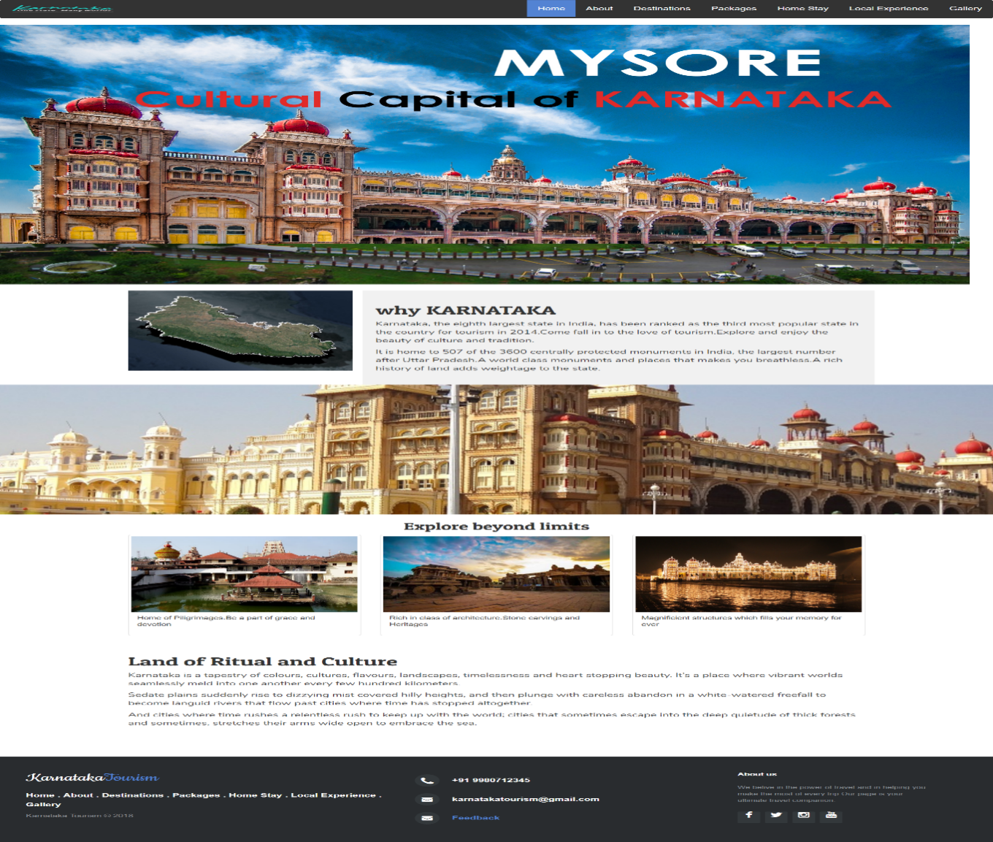

Fig 3.1: Home page

**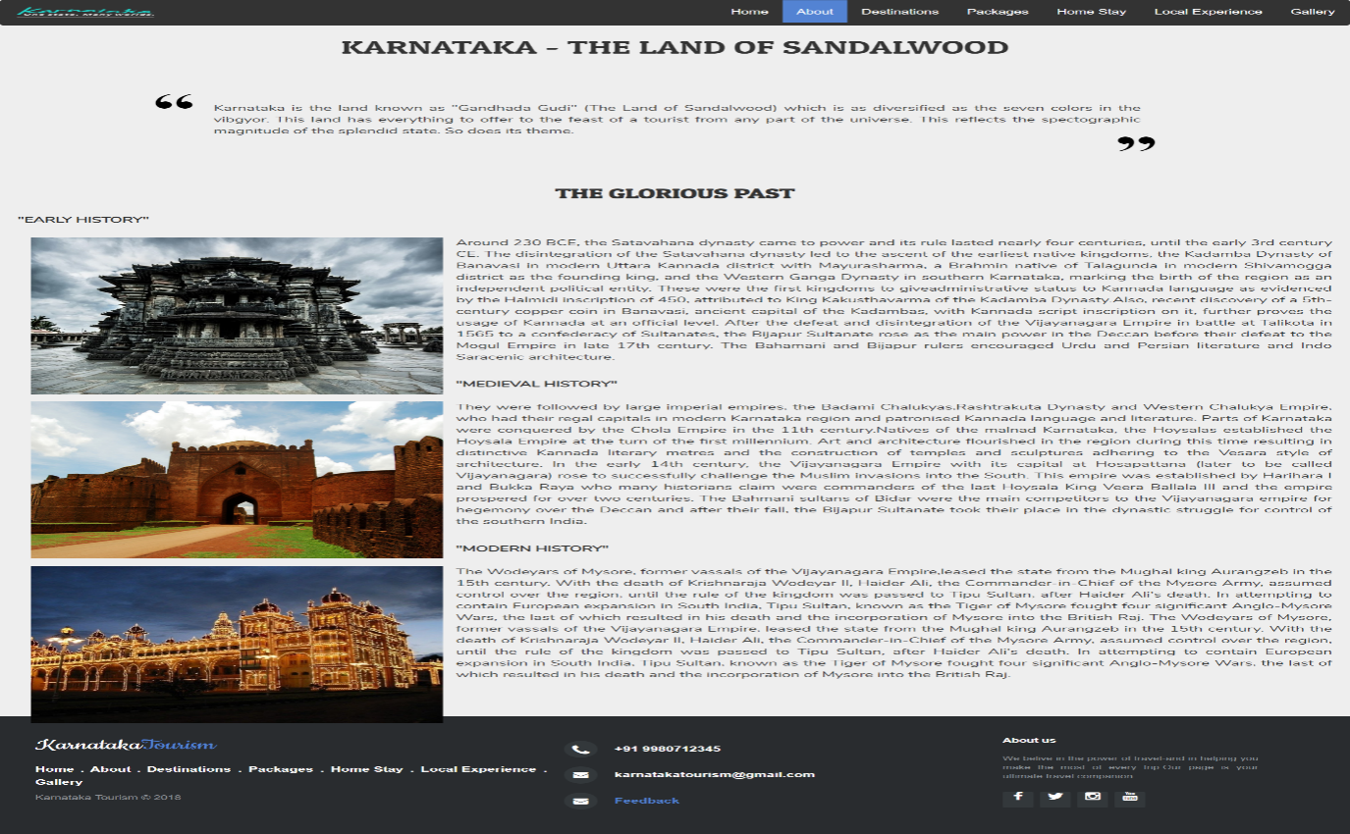**

Fig 3.2: About page

**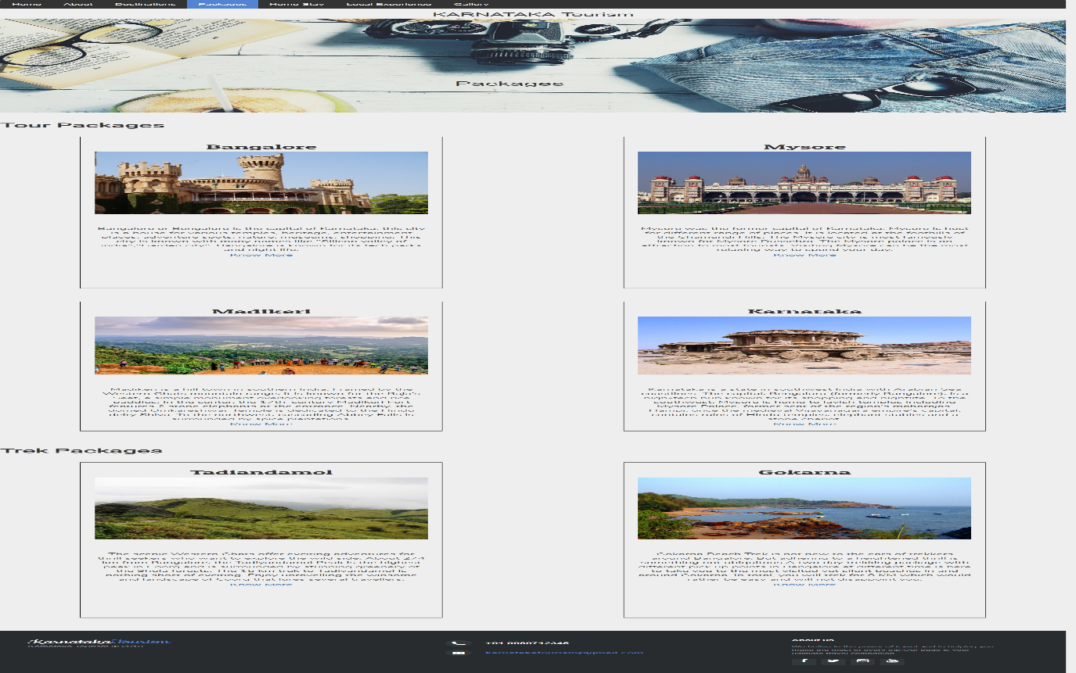**

Fig 3.3: Package page

**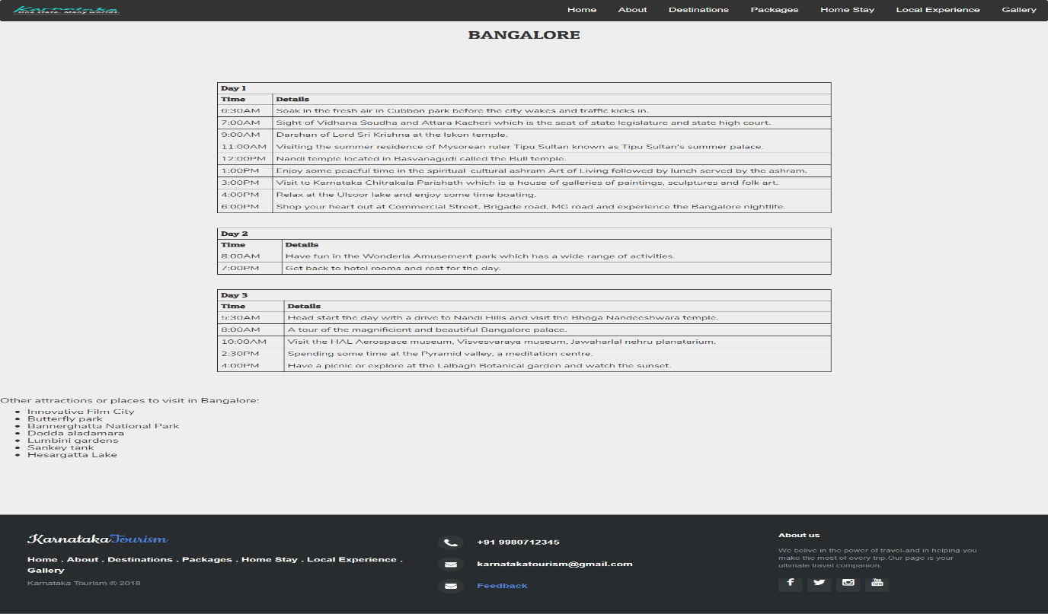**

Fig 3.4: Bangalore package page

**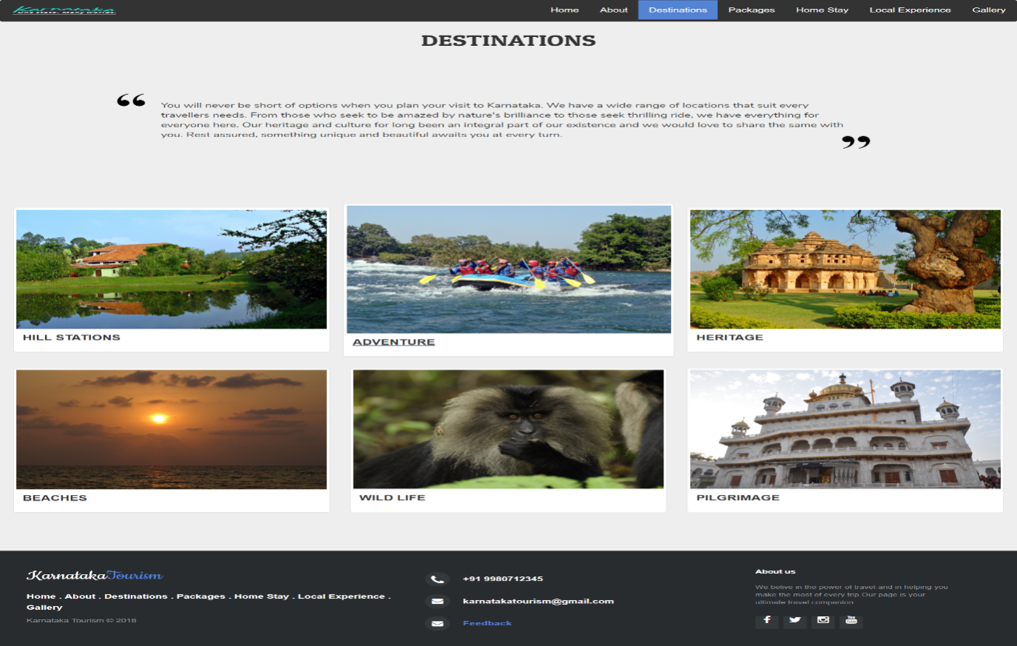**

Fig 3.5: Destinations page

**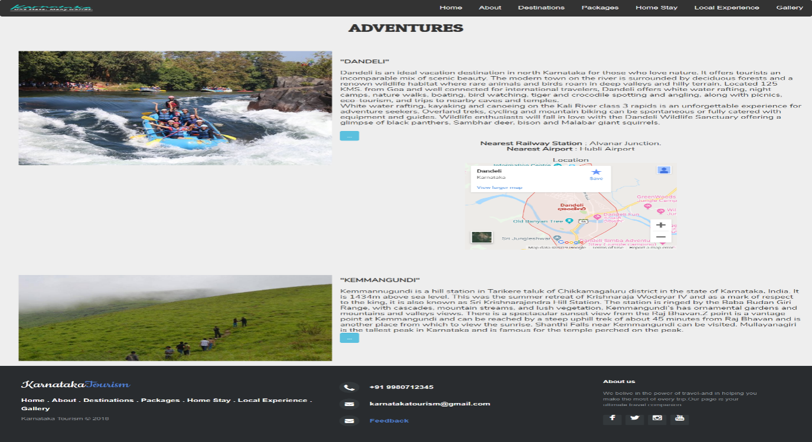**

Fig 3.6: Destinations-Adventures page

**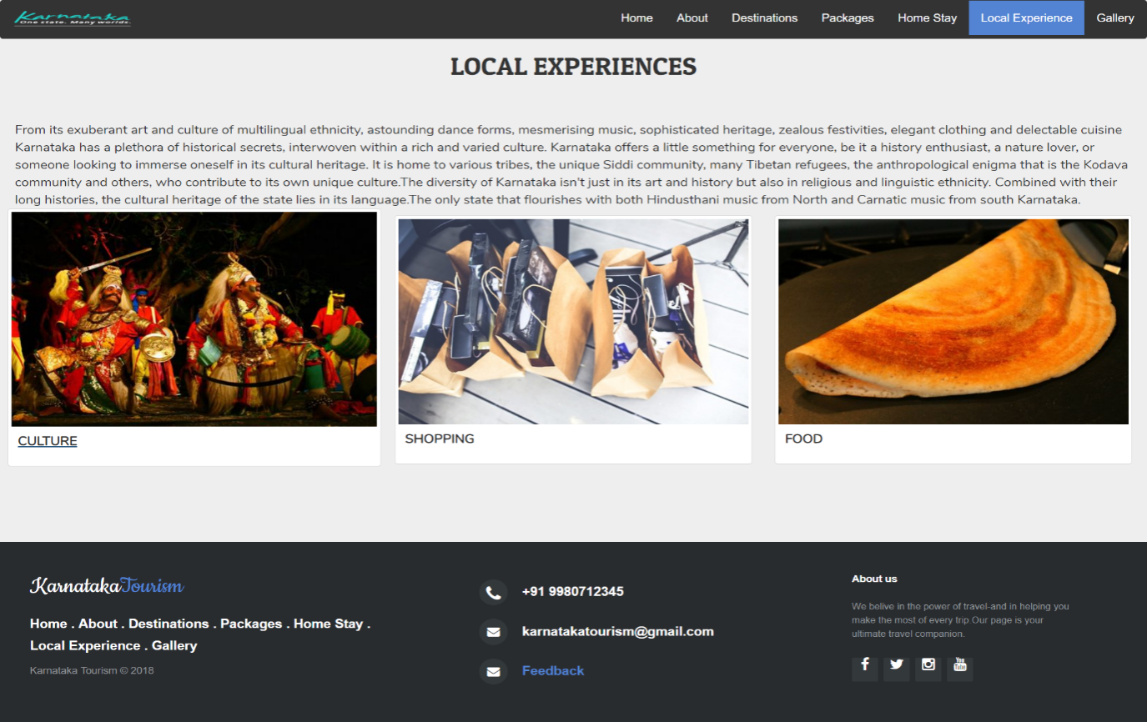**

Fig 3.7: Local Experience page

**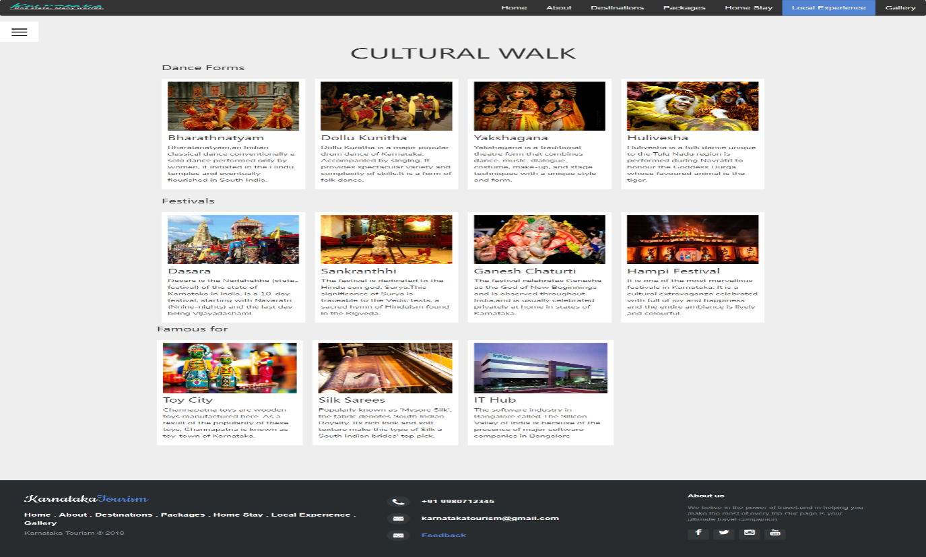**

Fig 3.8: Cultural page

**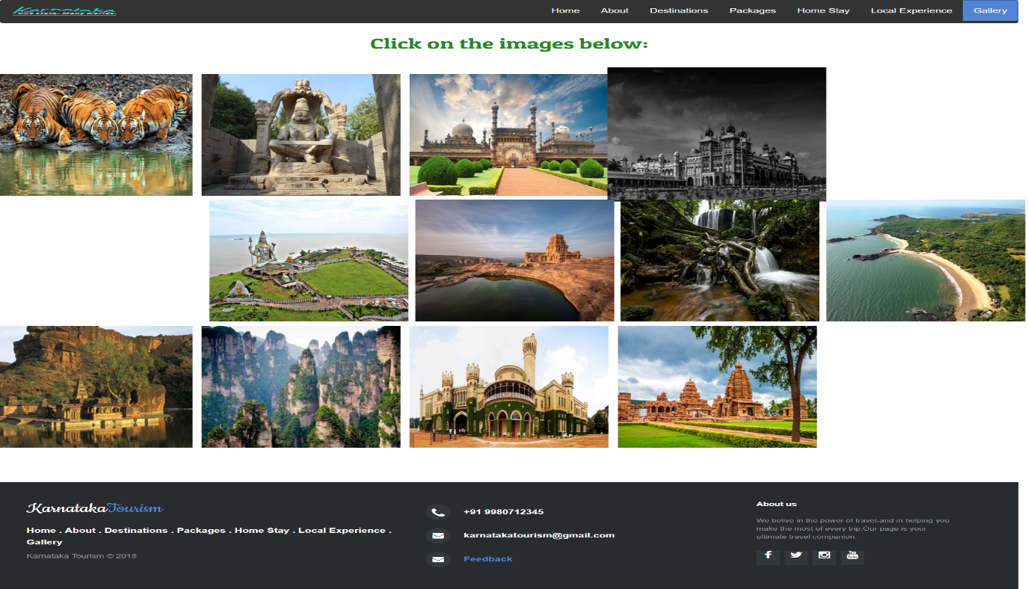**

Fig 3.9: Gallery page

**Chapter 4**

**REFLECTION NOTES**

During my work experience at Sookshma Chetas, I was fortunate enough to have experienced firsthand and learned, many different sides of what goes into a project, the general process of how a project is initially planned, developed and completed; as well as how much work and detail goes into every stage. Another valuable lesson I have learned during those 4 weeks were the many different types of work an Engineer has to perform, which in turn, have provided me with more insight into the different types of roles and responsibilities that I could perform, as a Computer Engineer.

Reflecting back to my first day at Sookshma Chetas, it was one of the most memorable days of my time at work. After being introduced to everyone, I was handed a project to work on, in which they had asked me to build a tourism website for an anonymous client. They were very open and happy for me to contribute as much as I wanted to, and were open to any suggestions and ideas. This instantly made me feel comfortable and definitely made me feel as though I was a major part of the team.

During the first week of work, I was overwhelmed by the work and the responsibilities that were placed on me, but with the help of my supervisors and the directors, who have had years of experience in the industry, I felt more confident and supported as I knew my work would be double checked and any uncertainties were explained. By observing and learning from them, I managed to pick up tips and learned different types of skills, from learning to communicate and deal with other companies, to reading and deciphering many different types of plans.  I was happy that I had the opportunity to use all of my theoretical knowledge and applied them to real‐life situations. Through experience and observation, another valuable lesson that I learned while working at was that in projects, especially when working in primary stages of certain project, things can change very quickly and dramatically. I ended up learning a lot more than I thought I would be able to in the time span. I am so happy, and proud that I have completed my internship on a positive note.

**TECHNICAL OUTCOMES**

* To develop and implement solutions to problems encountered in all phases of the design process.
* To create visual communications through the application of design theories and principles to develop effective design solutions.
* To apply typographic skills and knowledge to create effective visual communications.
* To apply a variety of technologies to create, capture, and manipulate design elements in producing a final product.
* To apply effective business practices and project management skills appropriate to his/her position in the web design field.
* To develop personal and professional strategies and plans to improve job performance and professional relationships with clients, coworkers, and supervisors.

**NON-TECHNICAL OUTCOMES**

* Self-reliance skills: To demonstrate that I can work independently. Self-awareness about our strengths. To organize and prioritize our commitments.
* People skills: being able to demonstrate interpersonal skills. To communicate effectively. To participate in team activities and sometimes take the lead.
* General skills: those skills that could be used in any situation and across all sectors. To demonstrate flexibility and solve challenging problems.
* Specialist skills: these are often gained through the studies, such as subject-specific knowledge or technical skills. This deals with how a particular organization works.

**EXECUTIVE SUMMARY**

This is an attempt to know how the theories can be applied to practical situation. As an undergraduate student, it is a part of the study to undergo internship at any organization. So for this purpose, I got an opportunity of training and internship at Sookshma Chetas Private Limited.

The report consists of four chapters. In the first chapter of the internship report, the general information about the company has been collected. Information has been gathered from the primary and secondary sources as well. In the second chapter, it contains the information about the department in which we specialized the internship. The third chapter consists of the tasks that were performed during the internship. Finally, the fourth chapter contains the reflection notes.

**REFERENCES**

[1] Randy Connolly, Ricardo Hoar, "Fundamentals of Web Development”, 1 stEdition, Pearson Education India. (ISBN:978-9332575271)

[2] Nicholas C Zakas, “Professional JavaScript for Web Developers”, 3rd Edition, Wrox/Wiley India, 2012.

[3] David Sawyer Mcfarland, “JavaScript & jQuery: The Missing Manual”, 1st Edition, O’Reilly/Shroff Publishers & Distributors Pvt Ltd, 2014.

[4] Zak Ruvalcaba Anne Boehm, “Murach's HTML5 and CSS3”, 3rdEdition, Murachs/Shroff Publishers & Distributors Pvt Ltd, 2016.

[5] www.W3Schools.com

[6] www.tutorialspoint.com